SOC Automation Project 2.0 – MyDFIR
AI-Driven Alert Enrichment & Automated Incident Reporting
Project Overview
This project demonstrates a Security Operations Center (SOC) automation workflow that integrates SIEM detection, threat intelligence enrichment, AI-based analysis, and automated Slack alerting.
The goal is to reduce Mean Time To Detect (MTTD) and Mean Time To Respond (MTTR) by automatically converting raw security alerts into context-rich, analyst-ready incident summaries
Objectives
- Detect suspicious authentication activity (brute-force attempts)
- Enrich Indicators of Compromise (IOCs) using threat intelligence
- Use AI to generate human-readable security summaries
- Automatically notify SOC analysts via Slack
- Simulate a real-world SOC automation pipeline
Architecture Overview
Endpoint Logs
│
▼
Splunk SIEM
│
(Alert Trigger)
▼
Webhook (SOAR)
│
▼
AI Analysis Engine
│
▼
Threat Intelligence Enrichment (AbuseIPDB)
│
▼
Slack Alert Channel (#alerts)

🖥️ Lab Environment
Virtualization Platform
- VMware Workstation
Machines Used
Machine | Role
Windows 10 | Endpoint (Event Log Source)
Ubuntu | Splunk Enterprise (SIEM)
Ubuntu | SOAR / Automation Engine
Ubuntu | IR / Analysis Node
Kali Linux | Attack Simulation
Tools & Technologies
- Splunk Enterprise – Log ingestion, detection, alerting
- Splunk Universal Forwarder – Endpoint log forwarding
- Slack – SOC alert notifications
- AbuseIPDB API – Threat intelligence enrichment
- AI Model (LLM) – Automated alert summarization
- Webhook-based SOAR workflow
- MITRE ATT&CK Framework
Detection Logic
Use Case: Brute Force Authentication Attempt
Splunk Query
index="beast005" EventCode=4625
This query detects failed login attempts from Windows Security logs.

Statistical Correlation
index="beast005" EventCode=4625
| stats count by _time, ComputerName, user, src_ip
Used to identify:
- Repeated authentication failures
- Source IP involved
- Targeted user account

Alert Configuration
- Alert Name: test-brute_force
- Trigger Condition: Detection of failed authentication events
- Action: Send event payload to SOAR Webhook

SOC Automation Workflow
1️⃣ Webhook Trigger
Splunk alert sends JSON payload containing:
- Source IP
- Username
- Hostname
- Event count
- Timestamp

2️⃣ AI-Based Analysis
The AI model:
- Interprets raw log data
- Determines attack context
- Maps activity to MITRE ATT&CK
- Generates analyst-friendly summary

3️⃣ Threat Intelligence Enrichment
AbuseIPDB API is queried to determine:
- Abuse confidence score
- ISP
- Country
- Known malicious behavior

4️⃣ Automated Slack Notification
A fully enriched incident report is sent to the #alerts channel.

Sample Slack Alert (Automated)
Summary
- Alert triggered due to suspicious activity originating from the source IP 134.209.201.69
- Multiple failed SSH login attempts detected
- Targeted common usernames such as admin and root
IOC Enrichment
- IP Address: 134.209.201.69
- Abuse Confidence Score: 100/100
- ISP: DigitalOcean, LLC
- Country: Netherlands
- Usage Type: Data Center / Hosting
MITRE ATT&CK Mapping
- T1110 – Brute Force
- T1078 – Valid Accounts
Severity
High
Recommended Actions
- Block IP at firewall
- Review authentication logs
- Monitor for lateral movement
- Enforce account lockout policies
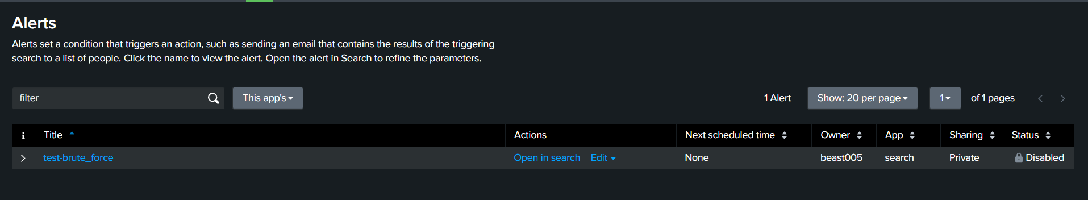
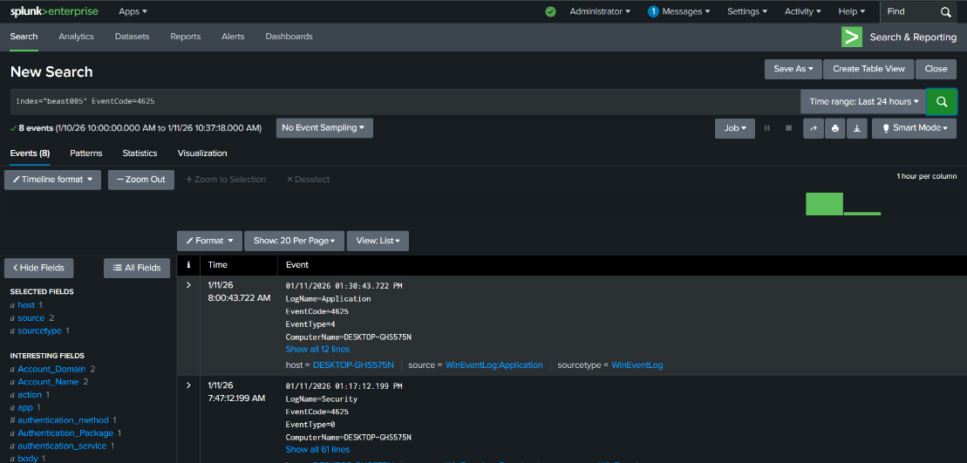
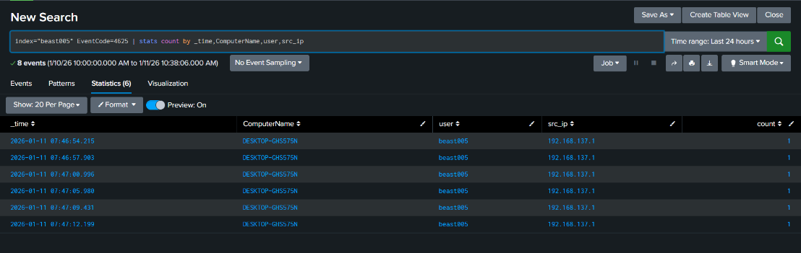
Internal vs External Attack Differentiation
The system correctly identifies private IP addresses (e.g., 192.168.137.1) as internal activity, reducing false positives and assigning lower severity when appropriate.
📊 Key Outcomes
✔ Automated detection → analysis → response
✔ Reduced manual SOC effort
✔ Context-rich alerts instead of raw logs
✔ Real-world SOC workflow simulation
✔ AI-assisted decision support
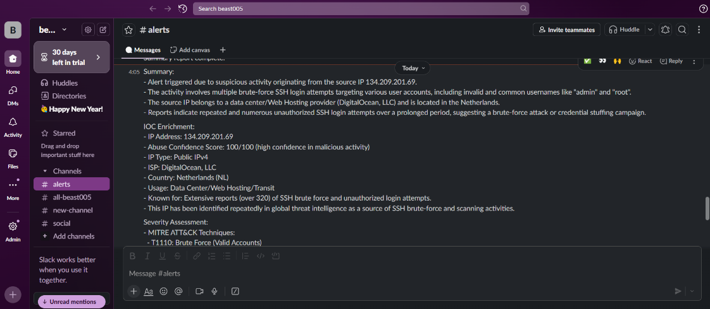
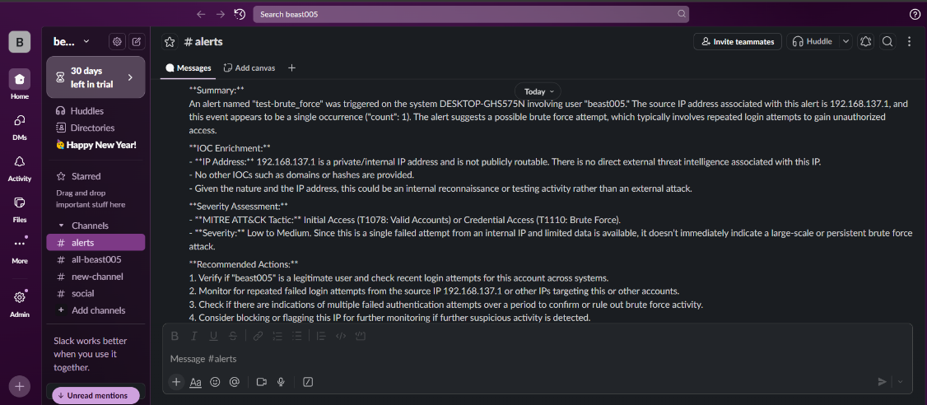
MITRE ATT&CK Coverage
Tactic | Technique
Initial Access | T1078 – Valid Accounts
Credential Access | T1110 – Brute Force
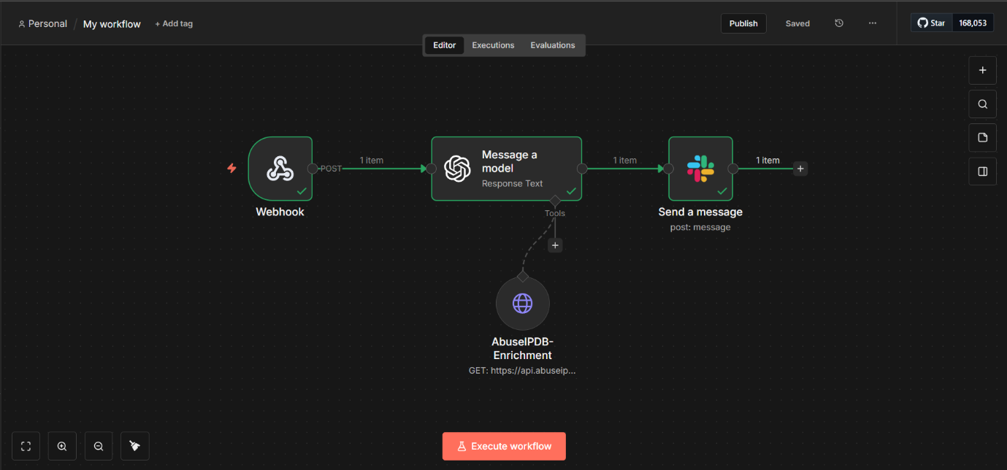
Repository Structure (Recommended)
SOC-Automation-Project-2.0/
│
├── screenshots/
│ ├── splunk-alert.png
│ ├── slack-alert.png
│ ├── workflow.png
│
├── queries/
│ ├── brute_force_detection.spl
│
├── report/
│ └── SOC_Automation_Report.md
│
└── README.md

Future Enhancements
- SOAR-based automatic IP blocking
- Ticket creation (Jira / ServiceNow)
- Risk scoring using ML
- Multi-source correlation (EDR + SIEM)
- Threat hunting dashboards

Conclusion
This project successfully demonstrates a modern SOC automation pipeline by combining SIEM, SOAR, AI, and threat intelligence.
It mirrors real enterprise SOC operations and showcases practical blue-team engineering skills.

